# AWD – Automated Whistler Detector

The AWD system identifies whistlers in broadband VLF data. Detailed analysis of these whistlers yields magnetospheric parameters. Traditionally performed by hand in an arduous and error-prone procedure, this analysis has been automated using an extended whistler inversion method. This procedure is, however, computationally expensive and for remote stations where network bandwidth prohibits the transfer of the raw data, analysis will take place on local supercomputers. An Automated Whistler Detector (AWD) station consists of two magnetic loop antennas, VLF preamplifier, VLF Receiver, VR2 VLF Sampler and AWD software running on x86 PC with a Linux kernel, see the *Figure 1*.

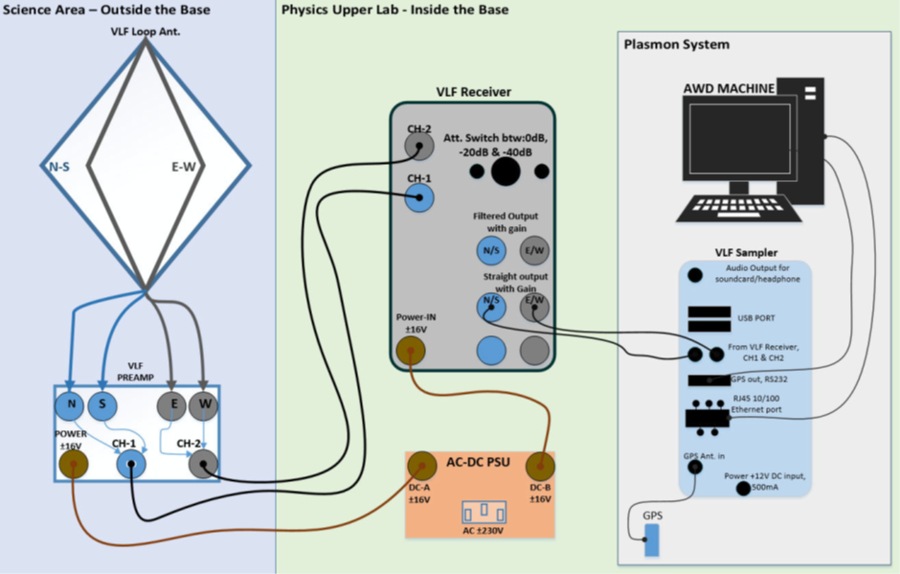

Figure 1. Diagram of connections to PLASMON system.

The processing of the VLF broadband waveform which contains whistlers composes of four computers system which are labelled AWD1, AWD2, AWD3 and AWD4, refer to *Figure 2*. All the AWD machines are connected via their onboard network interface cards (NIC) to a gigabit switch. This gigabit switch is connected to the SANAE network Table 2.2. AWD1 has an additional NIC which is connected the VLF Sampler (VR-2). It should have 1 serial port for GPS input and occasional boot up commanding. Though VR2 and the PC can be set to any IP address, it is preferable to put them on a separate network using a dedicated network card in the PC. This way the communication with VR2 is independent to any other network traffic and VR2 is protected from spikes induced in long Ethernet cable. AWD runs on 2.6.39.4 kernel. This kernel has a PPS patch that enables it to use Jupiter GPS card in VR2 as reference clock with NTP server. This way AWD PC can be used as a time server in the local network.

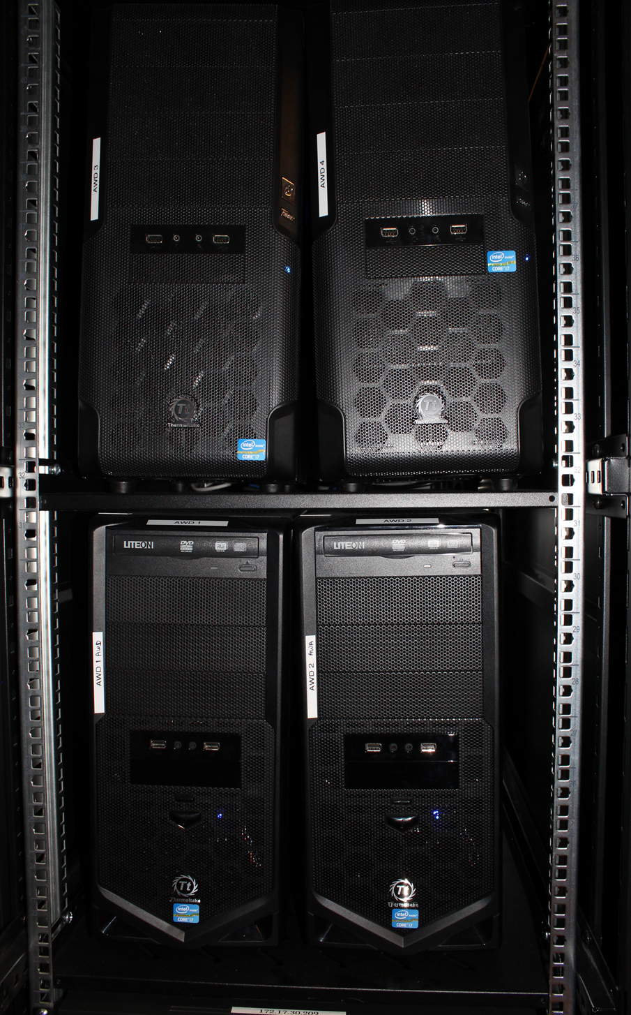

Figure 2. AWD computers in server rack.

VR2 has two input MINIDIN connectors as can be seen in *Figure 3*. Both differential and asymmetric input signal from VLF preamp can be connected. For asymmetric input a ’Y’ cable is supplied with two MINIDINs for CH1 and CH2 inputs and a 3.5 mm stereo jack plug.

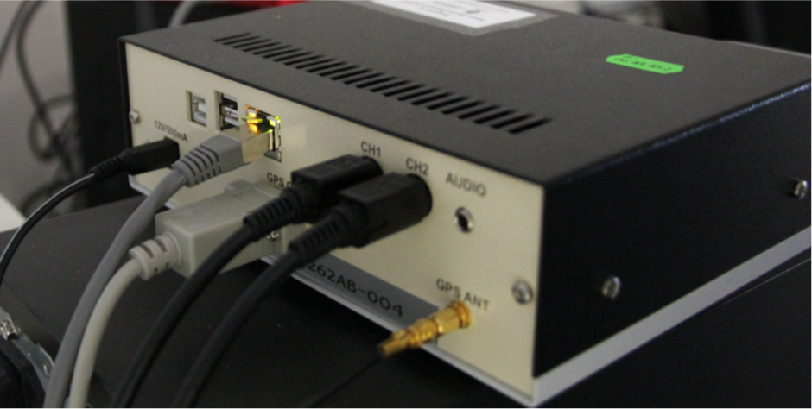

Figure 3. VR2 Sampler ports.

GPS OUT must be connected to COMM1 serial port on PC (ttyS0 in Linux), RJ45 has to be connected to Ethernet port on PCI card by cross over cable. The serial cable is standard straight cable are (if not supplied). The supplied small rectangular shape GPS antenna must be connected to ANT. GPS antenna has a small magnet on the bottom of its plate for easy mounting on the roof. A 12V PSU is supplied, but any PSU can be used if it supplies 500mA at 12V least.

The amplification of VR2 can be set via the DIP switch between 0dB and +30dB independently for the two channels. Though the amplification can be set for the two channels independently, it is better to keep them on the same level to avoid calibration problem. The signal level must be set to optimize ADC range: all samples should be within + 32765 (i.e., only strong spherics should reach this value).

There are another two DIP switches on for signal impedance matching. It can be used for matching VR2 input impedance with VLF signal cable’s one. It can be set to 50, 100, 200 or 620 Ohm. Mismatching causes decrease in signal level. 200 Ohm is good rough value for 2 300m long signal cable.

There are two times two jumpers behind these DIP switches. If they are on, the input signal is attenuated by 18dB. Both jumpers must be set on to set this attenuation for an input channel. The channels can be set independently.

There are two LEDs (a green marked ’NAV’ and a red marked ’GPS’) at front side of V21 box *Figure 4* serving for diagnostic purposes. When power is switched on, VR2 waits 5 second for command input through serial port, if no command received starts to boot from internal flash memory; during this time the LEDs are off. After start-up LEDs are blinking alternately waiting for the PC side data logger program to be started. If the PC side program runs, red led blinks 1/sec showing 1PPS is present. The green led is on when the GPS card inside VR2 navigates properly (sees enough satellites).

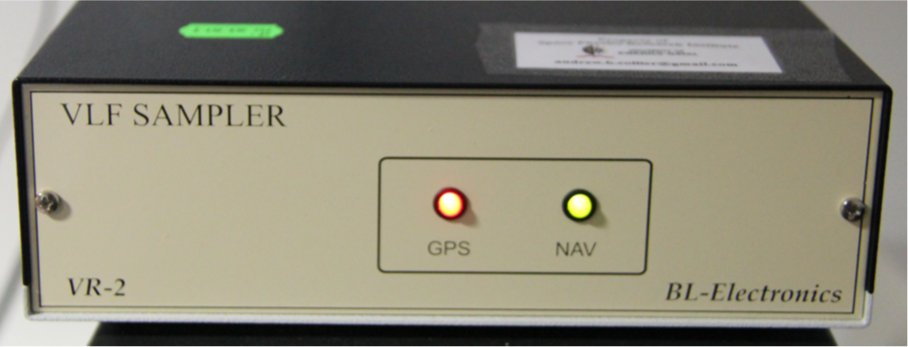

Figure 4. VR2 Sampler.

VR2 is setup upon PC program start-up, parameters can be set via vr2.conf file. vr2.conf must be in AWD ’root’ directory **(/u1/sanae/vr2)**, it is a simple ASCII file.VR2 has a DSP processor running a simple Linux kernel (blackfin) that:

* processes GPS navigation data,
* synchronize ADC clock (12.8MHz) to GPS PPS signal achieving 80nanosec timing accuracy,
* and puts data into frames and adds sync, status bytes and time stamp to the beginning of each frame.

Data collecting module is started through init system upon PC boot. There is a user level program called driver, it communicates with VR2 upon start-up and during data logging, it writes data to disk. It opens a file in every hour. The filename contains date and time info based on system (PC) time. This is just an approximate time of the first sample of file, the exact times can be found at each frame header. The filename format is yyyymmddUThh:mm:ss.sitename.vr2, e.g., 2018-05- 31UT01:59:45.14380156.sanae.vr2 and the data directory is **/u1/sanae/vr2/wh_vr2_rt/.**